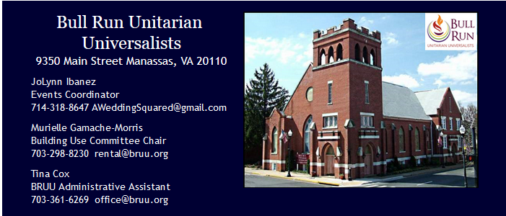
APPLICANT INFORMATION
The applicant will be responsible for the condition and cleanliness of the building at the end of the lease term. A checklist of duties required to be completed by the applicant or a responsible adult on their behalf can be found at the end of the application form.

First Name:_______________________________________________________________
Last Name: _______________________________________________________________
Street Address:____________________________________________________________
City: _____________________________________________________________________
State: ____________________________________________________________________
Zip Code: ___________________
E-mail: ___________________________________________________________________
Primary Contact Phone Number: _________________________________
Backup Phone Number: ________________________________________
Are you (check all that apply):
___ A Member of BRUU  ___ A Non-Profit Organization  ___ Sponsored by a BRUU Committee | ___ Part of the Administrative Staff of BRUU  ___ A Private Individual/Event  ___ Other

If you are sponsored by a BRUU Committee, list the sponsoring committee below:
_______________________________________________________________________________
EVENT

Brief description of the event:
_______________________________________________________________________________
_______________________________________________________________________________
_______________________________________________________________________________

Approximate number of attendees:
__________________________________________________________________

Is the Event:
___ Private
___ Free & Open to the Public
___ Open to the Public with a Cover/Ticket Price:

Will alcohol be served (if yes, please note our requirements regarding alcohol from page 1):
___ Yes
___ No

Will entertainment (band, D.J.) be included at the event?
___ Yes
___ No

Will there be extensive decorations (chair covers, balloons, streamers)?
___ Yes
___ No

TERMS OF USE

One Time Use Only
Date: ___________________________________________
Start Time: _______________________________________

Building will be cleaned and vacated by:
________________________________________
(Note: Building closes at 1:00 A.M., any occupancy after that time will be charged at $100 per hour or any fraction thereof.)

Set-Up/Decorating Date (For weddings and parties only)
________________________________________

Set-Up/Decorating Start Time (2 hours maximum)
________________________________________
Recurring Usage
Beginning Date:
__________________________________

Frequency
___ Daily
___ Weekly
___ Monthly
___ Other

Start Time: _________________________
End Time: __________________________

Facilities/Equipment Requested: (check all that apply)
___ Hall
___ Hall A/V System
___ Kitchen (for more than plating)
___ Lounge/Room 105/Changing Room
___ Sanctuary
___ Sanctuary Sound System
___ Piano** (Complete Piano Application and Acknowledgement)
___ Table/Chairs
___ Place settings/silverware (max 85 available)
___ Elevator
___ Library/Room 204
___ Classroom 208
___ Classroom 304/306
___ Classroom 305/307
___ 3rd Floor Studio/Chapel

Deposit Amount (check all that apply)
Note: Building space for an event cannot be reserved and placed on the calendar until this completed application and deposit (in full) are received.
___ $300 for sanctuary and/or hall rental
___ $100 for full kitchen use
___ $100 audio/visual rental
___ $50 for each classroom/chapel rentals

Other
In order to have your security deposit returned in an efficient manner, please printout, complete and return the Checklist of Rental Duties

Other Comments:
______________________________________________________________________________
______________________________________________________________________________

_______________________________________________________________________________

_______________________________________________________________________________

